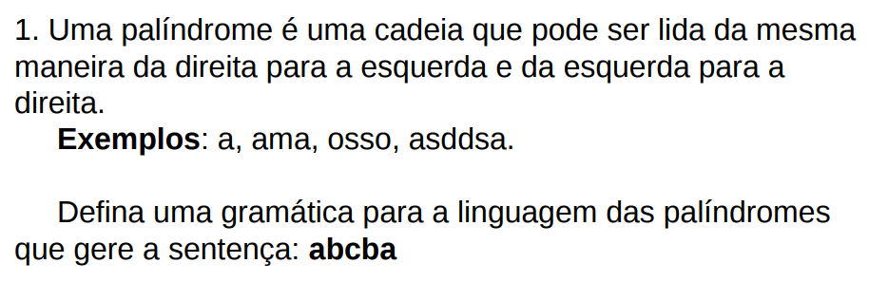

R:

S-> aAC

A->bB

b->c

C->ba

S->aAC

abBC

abcba

------------------------------------------------------------------------------------------------------------------------------

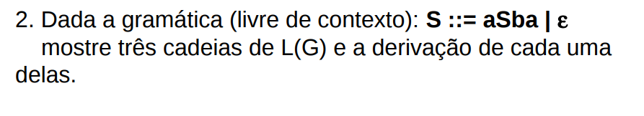

R:

S->aSba|&

->asba

->aaSbaba

->aa&baba

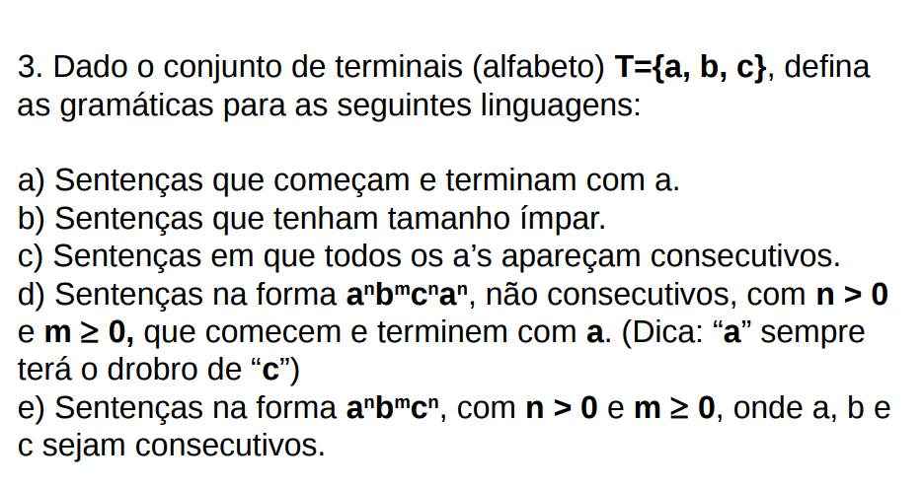

R:

A: S->abAca

A->abAca|&|B

B->caA|ab

B: S->aAb|bCa|bBa

A->aBc|bcA|a

B->bCa|cBc|b

C->cAb|abC|c

C: S-> A|AB|BA

A->a|aA|B

B->b|c|bB|cB

D: S->aSBa|aca

B->cC|c

C->b|bc|&

E:

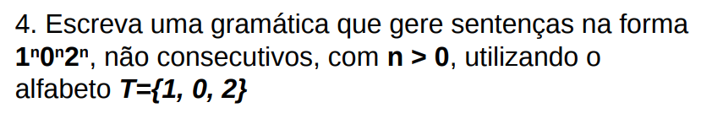

R:

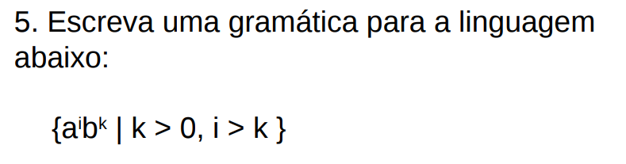R: